**Simian Output**

For Services Solutions: [0 Duplications]

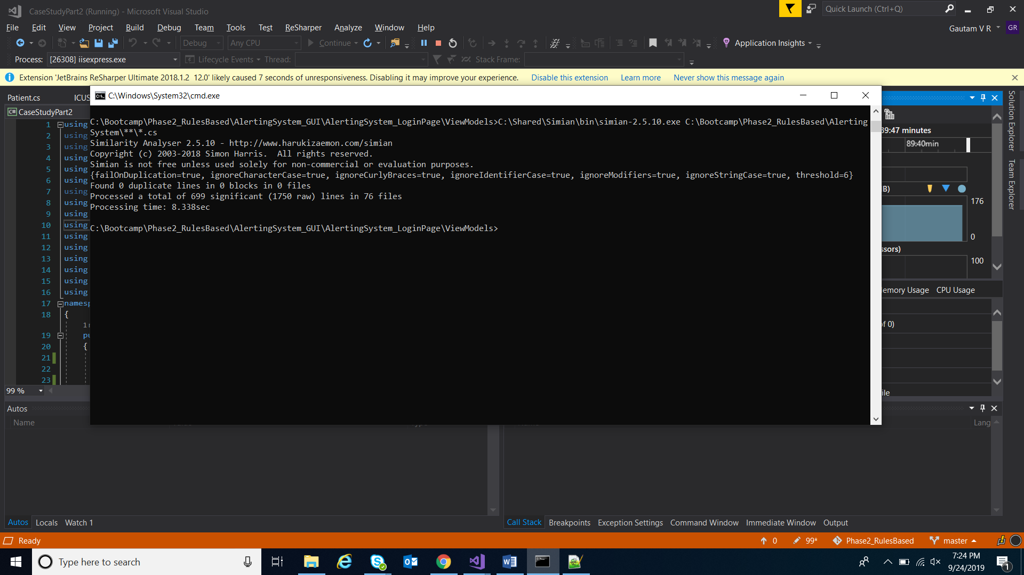

For UI Solutions: [0 Duplications]

